SQL CLASS - 7

TOPICS – SQL * Plus and its uses

SQL *Plus -

- SQL * Plus is Oracle’s developed environment tool (Look like Command Prompt).
- We can directly use SQL & PL/SQL statements in this environment tool.
- Only one SQL statement is managed in the SQL buffer.
- The current SQL statement replaces the previous SQL statement in the buffer.
- SQL statement can be divided into different line within the SQL buffer.
- Only one line i.e. the current line can be active at a time in the SQL buffer.
- In SQL prompt, editing is possible only in the current SQL buffer line.
- Every statement of SQL should be terminated using (;).
- To run the previous or current SQL statement in the buffer type ‘/’ at SQL prompt.
- To open the SQL editor type ed in SQL prompt.
- Some oracle function can be use only through SQL Plus. Like SQL Loader
- It provides…
- SQL commands
- PL/SQL block
- It has own commands to set environment as requirement like set page size, set line size, create spool file, etc.
- To generate report
- To save SQL command as .sql file.
- To save output as .lst file.( a text file)

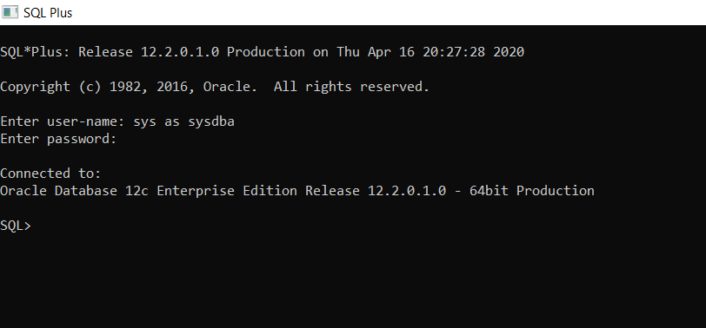

Spool file functions for .lst and .sql extension -
- Create spool file
- Reuse/Edit existing spool file
- Replace with existing spool file
- Get spool file
- Run Spool file
- See output of spool file
- Open spool file

Functions | .lst extension | .sql extension
Creating a Spool file | Syntax -  SPOOL file_location/file_name.lst;  SQL commands;  SPOOL OFF;  Example -  SPOOL D:\Spool_Files\oracle_text_file.lst;  SQL commands;  SPOOL OFF; | Syntax -  SPOOL file_location/file_name.sql;  SQL commands;  SPOOL OFF;  Example -  SPOOL D:\Spool_Files\oracle_text_file.sql;  SQL commands;  SPOOL OFF;
To reuse / edit existing spool file | Syntax -  SPOOL file_location/file_name APPEND;  SQL Commands;  SPOOL OFF;  Example -  SPOOL D:\Spool_Files\oracle_text_file.lst APPEND;  SQL Commands;  SPOOL OFF; | Syntax -  SPOOL file_location/file_name APPEND;  SQL Commands;  SPOOL OFF;  Example -  SPOOL D:\Spool_Files\oracle_text_file.sql APPEND;  SQL Commands;  SPOOL OFF;
To replace with existing spool file | Syntax -  SPOOL file_location/file_name REPLACE;  SQL Commands;  SPOOL OFF;  Example -  SPOOL D:\Spool_Files\oracle_text_file.lst REPLACE;  SQL Commands;  SPOOL OFF; | Syntax -  SPOOL file_location/file_name REPLACE;  SQL Commands;  SPOOL OFF;  Example -  SPOOL D:\Spool_Files\oracle_text_file.sql REPLACE;  SQL Commands;  SPOOL OFF;
To get the spool file | Syntax -  GET file_location/file_name;  Example -  GET D:\Spool_Files\oracle_text_file.lst; | Syntax -  GET file_location/file_name;  Example -  GET D:\Spool_Files\oracle_text_file.sql;
To run the spool file | Syntax -  RUN file_location/file_name;  Example -  RUN D:\Spool_Files\oracle_text_file.lst; | Syntax -  RUN file_location/file_name;  Example -  RUN D:\Spool_Files\oracle_text_file.sql;
To see the output of spool file | Syntax -  @ file_location/file_name;  Example -  @ D:\Spool_Files\oracle_text_file.lst; | Syntax -  @ file_location/file_name;  Example -  @ D:\Spool_Files\oracle_text_file.sql;
To open the spool file in editor | Syntax -  ed file_location/file_name;  Example -  ed D:\Spool_Files\oracle_text_file.lst; | Syntax -  ed file_location/file_name;  Example -  Ed D:\Spool_Files\oracle_text_file.sql;

SQL PLUS Commands-

SET LINESIZE (80) –

Sets the total number of characters that SQL*Plus displays on one line before beginning a new line.

Example – Set pagesize(300);

SET PAGESIZE (14) –
Sets the number of lines in each page.
Example – Set linesize(300);

CLEAR SCREEN OR Cl SCR –

To clear the screen

__________________________THANK YOU____________________________

